**GUVI**

**FULL STACK DEVELOPMENT – MERN**

**B51WD – ENGLISH**

**DAY 7 TASK – 25.08.2023**

**- BALAJI S**

**Q1.Solving problems using array functions on rest countries data (**[**https://restcountries.com/v3.1/all**](https://restcountries.com/v3.1/all)**).**

**a. Get all the countries from Asia continent /region using Filter function:**

<script>

        var request = new XMLHttpRequest();

        request.open('GET','https://restcountries.com/v3.1/all');

        request.send();

        request.onload = function(){

            var data = JSON.parse(request.responseText);

            var asian_countries = data.filter((element) => element.region == "Asia");

            console.log(asian_countries);

        }

    </script>

**Output:**

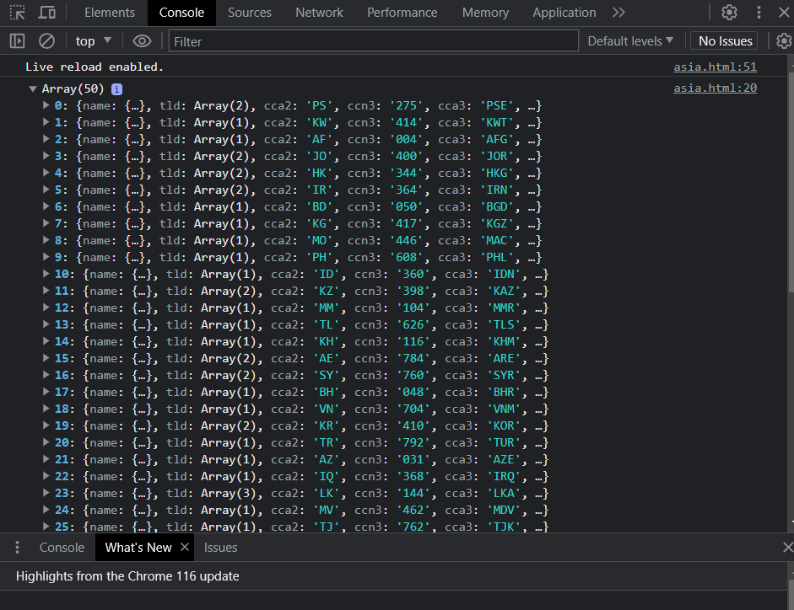

**b.Get all the countries with a population of less than 2 lakhs using filter function:**

<script>

        var request = new XMLHttpRequest();

        request.open('GET','https://restcountries.com/v3.1/all');

        request.send();

//countries with population less than 2 lakhs

        request.onload = function(){

            var data = JSON.parse(request.responseText);

            var pop = data.filter((element) => element.population > 200000);

            console.log(pop);

        }

    </script>

**Output:**

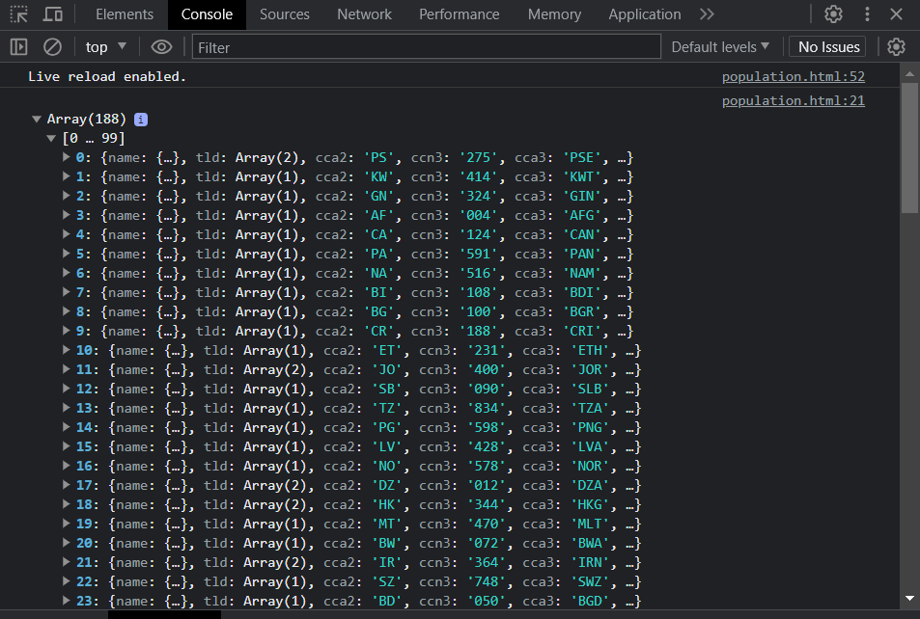

**c.Print all the countries name, capital and flag using foreach loop:**

<script>

        var request = new XMLHttpRequest();

        request.open('GET','https://restcountries.com/v3.1/all');

        request.send();

//countries with population less than 2 lakhs

        request.onload = function(){

            var data = JSON.parse(request.responseText);

data.forEach(element => {

                console.log(`Name:${element.name.common}`);

                console.log(`Capital:${element.capital}`);

                console.log(`Flag:${element.flag}`);

                console.log("---------------");

            });

        }

    </script>

**Output:**

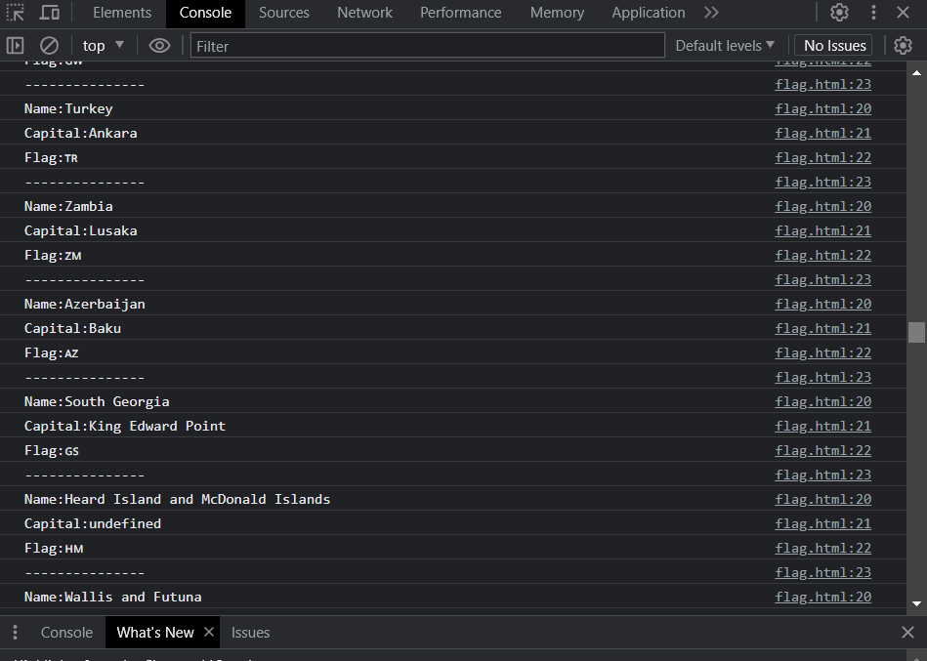

**d.Print the total population of countries using reduce function:**

<script>

        var request = new XMLHttpRequest();

        request.open('GET','https://restcountries.com/v3.1/all');

        request.send();

//total population of countries using reduce function

        request.onload = function(){

            var data = JSON.parse(request.responseText);

            var total_population = data.map((element) => element.population).reduce((acc,cv) => acc+cv);

            console.log(total_population);

        }

    </script>

**Output:**

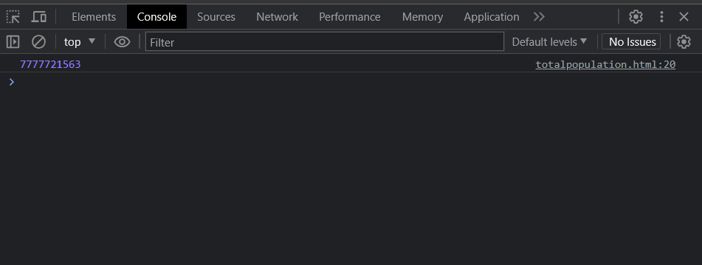

**e. Print the country which uses US dollars as currency.**

<script>

        var request = new XMLHttpRequest();

        request.open('GET','https://restcountries.com/v3.1/all');

        request.send();

//countries which uses US dollars as currency

        request.onload = function(){

            var data = JSON.parse(request.responseText);

            data.forEach(element => {

                var country = element.name.common;

                var currency = element.currencies;

                if(currency.hasOwnProperty('USD')){ //hasOwnProperty method checks whether USD is used by the countries currency array

                    console.log(country);

                }

            }

            )

        }

    </script>

**Output:**

